**UNIVERSITY OF TURBAT**



**Submitted by: Arman**

**Program:** BS (CS), 4th semester (Fall 2025)

**Date of Submission: 11-Dec-25**

***Web_Technologies***

**My Portfolio-Website**

**1 ) . Introduction**

The Personal Portfolio Website is a modern, responsive web application developed to showcase my professional skills, work experience, projects, and digital capabilities. The purpose of this system is to create a strong personal brand identity and provide potential clients, recruiters, and collaborators an easy way to explore my expertise.

The website uses HTML, CSS, and JavaScript and includes interactive features such as animated text, smooth scrolling, responsive layouts, and dynamic hero section animations.

---------------------------------------------------------------------------------------------------------------------

## ****Why I Created This Portfolio Website****

### **1. To Build a Professional Identity**

In today’s digital world, having a personal website is very important.  
It works as my **online profile**, helping people recognize me as a professional.

### **2. To Showcase My Skills**

The website clearly highlights my abilities such as **web designing**, **social media management**, **content creation**, and more.  
It shows what I am good at and how I can help clients grow.

### **3. To Display My Projects**

All of my completed work and projects are presented in one place.  
This acts as **proof of my skills**, making it easier for clients to trust my work.

### **4. To Make Contact Easy**

My **email and WhatsApp** are directly listed on the website, so anyone can reach me fast without any complications.

### **5. To Build a Personal Brand**

This portfolio doesn’t just describe me—it strengthens my **personal brand** and makes my presence stand out online.

**6. To Create Future Opportunities**

Whether I apply for a job, take freelance work, or connect with new clients, this portfolio gives a **strong first impression** and helps me get better opportunities in the future.

**1.1 ) . Website Overview**

The portfolio contains the following main sections:

1. **Home**
2. **About**
3. **Skills**
4. **Projects**
5. **Contact**

Each section has its own purpose and functionality.

**2 ) . Scope of the Website**

This portfolio website includes the following functional and visual components:

1. **Home Section**
2. **About Section**
3. **Skills Section**
4. **Projects Section**
5. **AI Images Section**
6. **Contact Form Section**
7. **Typing Animation**
8. **Responsive Navigation Bar**
9. **Smooth Scroll Behavior**
10. **Animated Floating Profile Image**

The scope covers front-end design and basic form handling using an external API (Formspree).

**3 ) . System Overview**

The system is fully front-end based. It does not require server-side programming except for the contact API.  
The architecture is:

**Presentation Layer:** HTML, CSS

**Interaction Layer:** JavaScrip

**API Layer:** Formspree for form submission

**Storage:** None (no backend database included)

**4. Website Structure**

The website consists of several key modules:

# 5.1) . ****Home Page (index.html)****

### **Purpose:**

The Home Page is the landing section of my portfolio. It introduces me instantly with a beautiful visual layout.

### **Main Features:**

* A large hero section with my name and profession
* Typing text animation showing multiple roles
* My profile picture with sliding animation
* Dark-themed modern UI
* Background image for attractive appearance
* Sticky navigation bar to access all pages

### **What This Page Shows:**

* Who I am
* What I do
* My first impression as a designer and developer

**User Experience:**

The visitor understands my identity in the first 3 seconds.

------------------------------------------------------------------------------------------------------------------------------------------------------------------------------------------------------------------------------------------------------------------------------------

**Code:**

<!DOCTYPE html>

<html lang="en">

<head>

  <meta charset="UTF-8" />

  <meta name="viewport" content="width=device-width, initial-scale=1.0" />

  <title>My Portfolio</title>

  <style>

    body {

      margin: 0;

      font-family: Arial, sans-serif;

      background: #0d0d0d;

      color: #ffffff;

      scroll-behavior: smooth;

    }

    nav {

      width: 100%;

      padding: 20px 0;

      background: #09415571;

      position: sticky;

      top: 0;

      z-index: 999;

      display: flex;

      flex-wrap: wrap;

      justify-content: left;

      gap: 15px;

      border-radius: 15px;

    }

    nav a {

      color: #e8eee8;

      text-decoration: none;

      font-size: 18px;

      padding: 8px 14px;

      transition: 0.1s;

      font-family: 'Trebuchet MS', sans-serif;

    }

    nav a:hover {

      color: #0f1011;

      background-color: rgb(241, 233, 12);

      border-radius: 9px;

    }

    .hero {

      display: flex;

      justify-content: space-between;

      align-items: center;

      padding: 60px 20px;

      height: 60vh;

      background-image: url("portfiloo web image.jpg");

      background-size: cover;

      background-position: center;

      animation: fadeIn 1.5s ease-in-out;

    }

    .hero-left h1 {

      font-size: 50px;

      font-weight: bold;

      color: rgb(185, 210, 230);

    }

    .hero-right img {

      height: 600px;

      object-fit: cover;

      border-radius: 80px;

      padding-left: 9cm;

      padding-bottom: 1cm;

      position: relative;

      animation: slideRight 10s linear infinite alternate;

    }

    @keyframes slideRight {

      0% { left: 0; }

      100% { left: 50px; }

    }

    .section {

      padding: 60px 20px;

      max-width: 1000px;

      margin: auto;

      color: #80ceeb;

      animation: fadeIn 1.5s ease-in-out;

    }

    .section h2 {

      font-size: 32px;

      margin-bottom: 20px;

      border-left: 5px solid #922121;

      padding-left: 10px;

      border-radius: 20px;

    }

    .contact {

      background-color: #020c1d2e;

      color: #0ae6ee;

      border-radius: 15px;

      padding: 30px;

    }

    .contact input, .contact textarea {

      width: 90%;

      padding: 10px;

      margin: 10px 0;

      border-radius: 5px;

      border: none;

      background: #191818;

      color: rgb(238, 236, 236);

    }

    .contact button {

      padding: 12px 20px;

      background: #ffffff;

      color: #111111;

      border: none;

      border-radius: 8px;

      cursor: pointer;

      transition: 0.3s;

    }

    .contact button:hover { background: #f3ef06; }

    footer {

      text-align: center;

      padding: 20px;

      background: #111;

      margin-top: 40px;

      color: #777;

    }

    /* Responsive */

    @media (max-width: 768px) {

      .hero {

        flex-direction: column;

        text-align: center;

        height: auto;

      }

      .hero-right img {

        padding-left: 0;

        margin-top: 20px;

        width: 250px;

        height: 250px;

      }

    }

  </style>

</head>

<body>

  <!-- Navigation -->

  <nav>

    <a href="#home">Home</a>

    <a href="about.html">About</a>

    <a href="skills.html">Skills</a>

    <a href="project.html">Projects</a>

    <a href="#contact">Contact</a>

  </nav>

  <!-- Home Section -->

  <section class="hero" id="home">

    <div class="hero-left">

      <h1>

        <span id="typed-text"></span><span class="cursor">|</span>

      </h1>

    </div>

    <div class="hero-right">

      <img src="my own pic.png" alt="My Picture">

    </div>

  </section>

  <!-- Contact Section -->

  <section class="section contact" id="contact">

    <h2>Contact Me</h2>

    <form action="https://formspree.io/f/xgvqyeon" method="POST">

      <input type="text" name="name" placeholder="Your Name" required>

      <input type="email" name="email" placeholder="Enter your Own Email" required>

      <textarea name="message" placeholder="Your Message" required></textarea>

      <button type="submit">Send Message</button>

    </form>

  </section>

  <!-- Footer -->

  <footer>

    © 2025 My Portfolio — All Rights Reserved

  </footer>

  <script>

    const texts = [

      "Hello, I'm Arman",

      "I am a Web Designer",

      "I am a Social Media Expert",

      "I create AI Images & Videos",

      "I am a Content Creator",

    ];

    let currentText = 0;

    let charIndex = 0;

    const typedText = document.getElementById("typed-text");

    function type() {

      if (charIndex < texts[currentText].length) {

        typedText.textContent += texts[currentText].charAt(charIndex);

        charIndex++;

        setTimeout(type, 90);

      } else {

        setTimeout(deleteText, 1500);

      }

    }

    function deleteText() {

      if (charIndex > 0) {

        typedText.textContent = texts[currentText].substring(0, charIndex - 1);

        charIndex--;

        setTimeout(deleteText, 50);

      } else {

        currentText = (currentText + 1) % texts.length;

        setTimeout(type, 90);

      }

    }

    type();

  </script>

</body>

</html>

**Page Output :** 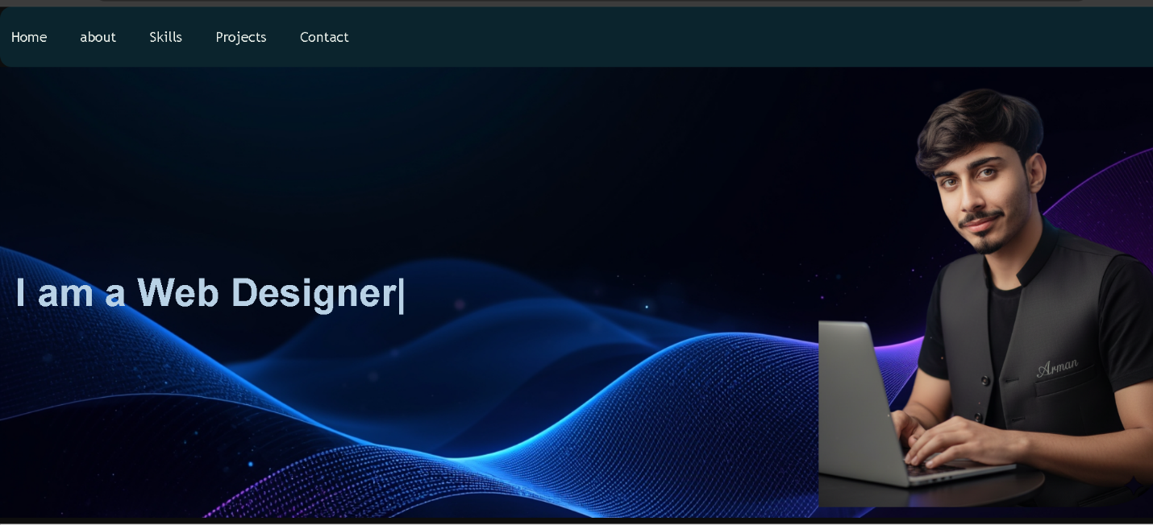

--------------------------------------------------------------------------------------------------------------------------------------------

# ****5.2 ) . About Page (about.html)****

### **Purpose:**

The About Page gives a clear and detailed introduction about my background, personality, skills, and interests.

### **Main Contents:**

* My introduction
* My passion for web development
* My experience in digital designing
* My journey in AI content creation
* My strengths and unique qualities

### **What This Page Shows:**

* My story as a creator
* Why I love designing & development
* Why clients should choose me

### **User Experience:**

They get a personal connection and trust about who I am.

<!DOCTYPE html>

<html lang="en">

<head>

  <meta charset="UTF-8">

  <meta name="viewport" content="width=device-width, initial-scale=1.0">

  <title>About Me</title>

  <style>

    body {

      margin: 0;

      font-family: Arial, sans-serif;

      background: url('portfiloo web image.jpg') no-repeat center center fixed;

      background-size: cover;

      color: #fff;

    }

    /* Left-side navigation */

    nav {

      width: 220px;

      height: 100vh;

      position: fixed;

      top: 0;

      left: 0;

      background-color: rgba(0,0,0,0.8);

      display: flex;

      flex-direction: column;

      padding-top: 50px;

    }

    nav a {

      color: #fff;

      text-decoration: none;

      font-size: 1.2em;

      padding: 15px 20px;

      transition: 0.3s;

    }

    nav a:hover, nav a.active {

      background-color: #00ffea;

      color: #000;

    }

    /* Main content */

    .main {

      margin-left: 220px;

      padding: 50px 30px;

    }

    .about-container {

      display: flex;

      flex-wrap: wrap;

      gap: 50px;

      justify-content: flex-start; /* image left */

      align-items: center;

      background-color: rgba(0,0,0,0.5);

      border-radius: 20px;

      padding: 40px;

      box-shadow: 0 0 30px rgba(0,0,0,0.7);

    }

    .about-image {

      flex: 0 0 350px; /* fixed width for image */

      text-align: center;

    }

    .about-image img {

      width: 100%;

      height: auto;

      object-fit: cover;

      border-radius: 0; /* no frame */

      box-shadow: none; /* remove shadow */

    }

    .about-text {

      flex: 1;

      min-width: 300px;

    }

    .about-text h1 {

      font-size: 3em;

      margin-bottom: 20px;

      color: #00ffea;

      text-shadow: 2px 2px 4px #000;

    }

    .about-text p {

      font-size: 1.2em;

      line-height: 1.8;

      margin-bottom: 20px;

    }

    .highlight {

      color: #00ffea;

      font-weight: bold;

    }

    footer {

      text-align: center;

      padding: 20px;

      background-color: rgba(0,0,0,0.7);

      margin-top: 50px;

    }

    /* Responsive */

    @media(max-width: 768px){

      nav {

        width: 100%;

        height: auto;

        position: relative;

        flex-direction: row;

        justify-content: space-around;

        padding: 10px;

      }

      .main {

        margin-left: 0;

        padding: 20px;

      }

      .about-container {

        flex-direction: column;

        padding: 20px;

        text-align: center;

      }

      .about-image {

        flex: none;

        width: 250px;

        margin-bottom: 20px;

      }

      .about-text h1 {

        font-size: 2.5em;

      }

    }

    .about-image img {

  width: 100%;

  height: auto;

  object-fit: cover;

  border-radius: 0; /* no frame */

  box-shadow: none; /* remove shadow */

  /* Animation */

  position: relative;

  animation: moveRight 4s ease-in-out infinite alternate;

}

/* Keyframes for left to right movement */

@keyframes moveRight {

  0%   { left: 0; }

  50%  { left: 20px; } /* move 20px to the right */

  100% { left: 0; }

}

  </style>

</head>

<body>

  <nav>

    <a href="Index.html">Home</a>

    <a href="about.html" class="active">About</a>

    <a href="skills.html">Skills</a>

    <a href="project.html">Projects</a>

    <a href="Index.html">Contact</a>

  </nav>

  <div class="main">

    <div class="about-container">

      <div class="about-image">

        <img src="222222222.png" alt="My Picture">

      </div>

      <div class="about-text">

        <h1>About Me</h1>

        <p>Hello! I'm <span class="highlight">Arman Nawaz </span>, a passionate <span class="highlight">Web Designer</span> and <span class="highlight">Social Media Expert</span>. I love combining creativity with technology to build amazing digital experiences.</p>

        <p>I create <span class="highlight">SEO-based content ideas</span>, manage <span class="highlight">YouTube channels</span>, design <span class="highlight">social media posters</span>, and run <span class="highlight">Facebook pages</span>. My goal is to help brands grow online with engaging content and stunning visuals.</p>

        <p>I am always learning new skills, exploring trends, and finding innovative ways to make digital content more impactful and memorable.</p>

      </div>

    </div>

  </div>

  <footer>

    © 2025 My Portfolio — All Rights Reserved

  </footer>

</body>

</html>

**Page Output:** 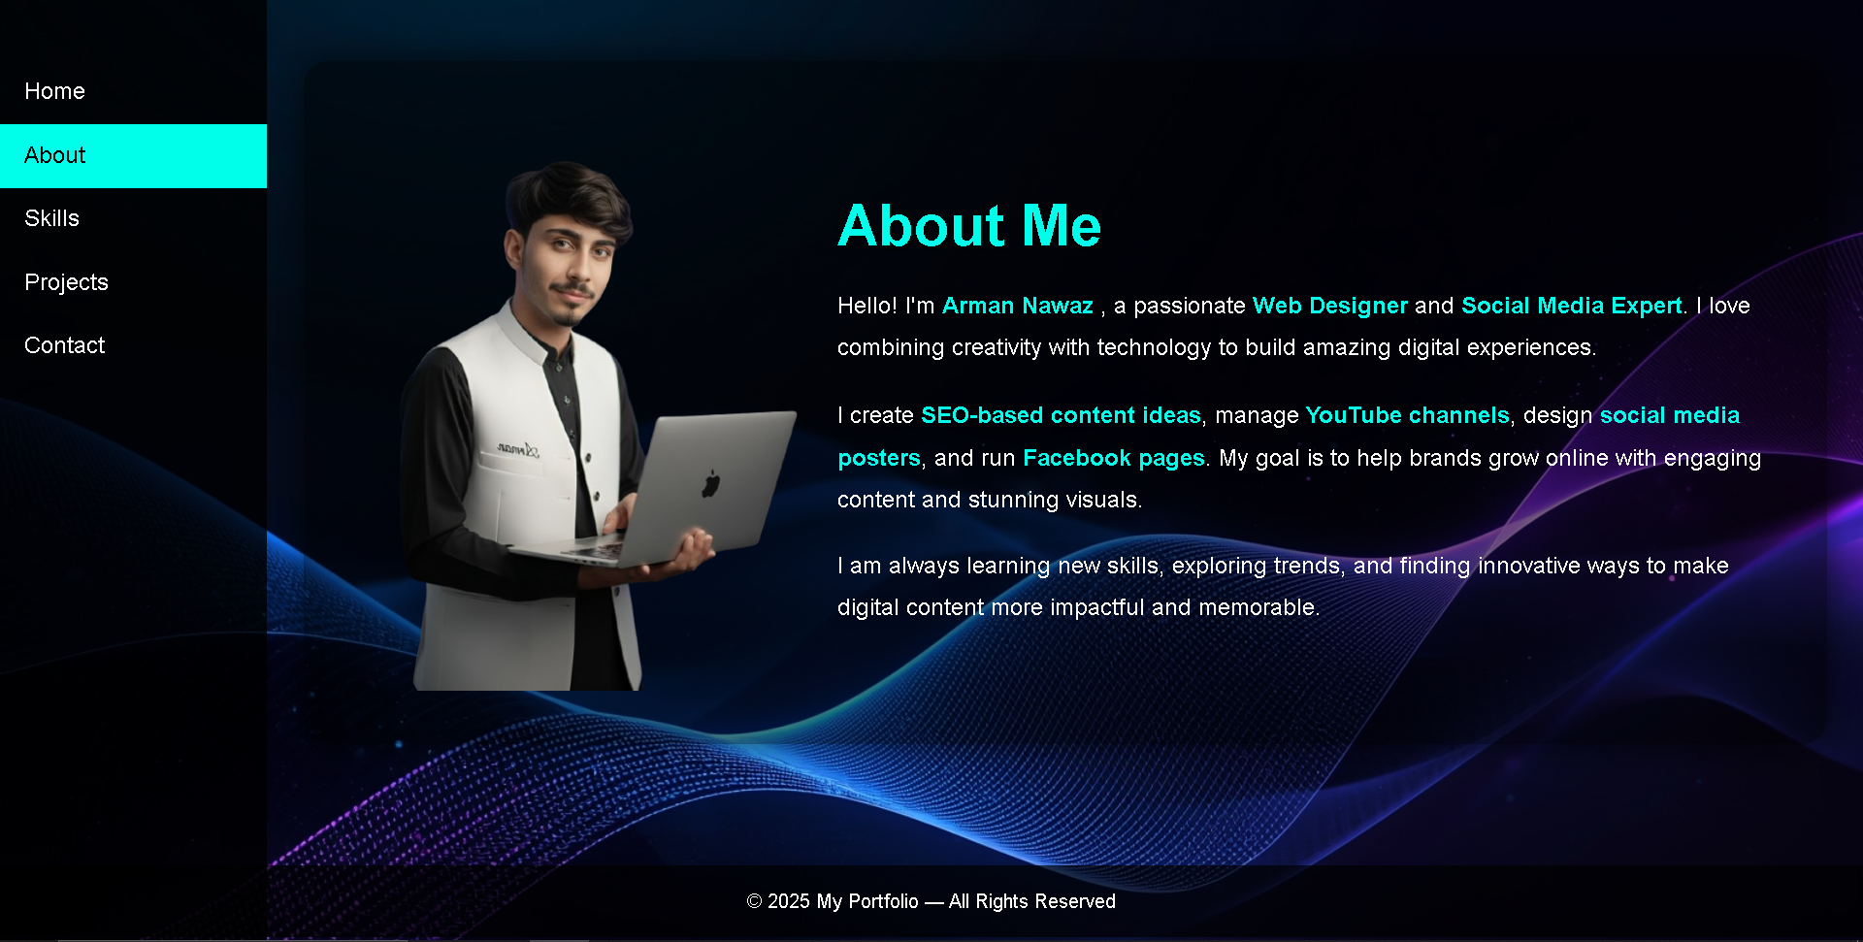

--------------------------------------------------------------------------------------------------------------------------------------------

# ****5.3) . Skills Page (skills.html)****

### **Purpose:**

To display all my technical and creative skills in a clean and structured way.

### **Skills Displayed:**

* HTML
* CSS
* JavaScript
* Web App Development
* Social Media Management
* Poster Designing
* AI Image Creation
* AI Video Editing
* Web Designing
* Content Creation

### **Layout & Style:**

* Skill boxes or cards
* Icons or simple list
* Clean typography
* Easy-to-read format

### **What This Page Shows:**

All abilities I have as a developer, designer, and digital creator.

### **User Benefit:**

They quickly understand my strengths.

---------------------------------------------------------------------------------------------------------------------

**Code:**

<!DOCTYPE html>

<html lang="en">

<head>

  <meta charset="UTF-8" />

  <meta name="viewport" content="width=device-width, initial-scale=1.0" />

  <title>My Skills</title>

  <style>

    body {

      margin: 0;

      font-family: Arial, sans-serif;

      background: url(my\ web\ about\ backh=ground\ pic.jpg) no-repeat center center fixed;

      background-size: cover;

      color: #fff;

    }

    /* Left-side navigation */

    nav {

      width: 220px;

      height: 100vh;

      position: fixed;

      top: 0;

      left: 0;

      background-color: rgba(0,0,0,0.8);

      display: flex;

      flex-direction: column;

      padding-top: 50px;

    }

    nav a {

      color: #fff;

      text-decoration: none;

      font-size: 1.2em;

      padding: 15px 20px;

      transition: 0.3s;

    }

    nav a:hover, nav a.active {

      background-color: #c2f009;

      color: #000;

    }

    /* Main content */

    .main {

      margin-left: 220px;

      padding: 50px 30px;

    }

    h1 {

      text-align: center;

      font-size: 3em;

      margin-bottom: 50px;

      text-shadow: 2px 2px 4px #000;

    }

    .skill {

      margin: 20px 0;

    }

    .skill-name {

      font-size: 1.2em;

      margin-bottom: 5px;

    }

    .skill-bar {

      width: 100%;

      background-color: rgba(19, 164, 232, 0.381);

      border-radius: 25px;

      overflow: hidden;

    }

    .skill-bar-fill {

      height: 25px;

      width: 0;

      background-color: #e90de1;

      text-align: right;

      padding-right: 10px;

      line-height: 25px;

      border-radius: 25px;

      font-weight: bold;

      transition: width 2s ease-in-out;

    }

    footer {

      text-align: center;

      padding: 20px;

      background-color: rgba(0,0,0,0.7);

      margin-top: 50px;

    }

    /* Responsive for mobile */

    @media (max-width: 768px) {

      nav {

        width: 100%;

        height: auto;

        position: relative;

        flex-direction: row;

        padding: 10px;

        justify-content: space-around;

      }

      .main {

        margin-left: 0;

        padding: 20px;

      }

    }

    #my{

      color: #09e4f0;

      padding-top: 2cm;

    }

  </style>

</head>

<body>

  <nav>

    <a href="Index.html">Home</a>

    <a href="about.html">About</a>

    <a href="skills.html">Skills</a>

    <a href="project.html">Projects</a>

    <a href="Index.html">Contact</a>

  </nav>

  <div class="main">

    <h1 id="my">My Skills</h1>

    <div class="skill">

      <div class="skill-name">HTML</div>

      <div class="skill-bar">

        <div class="skill-bar-fill" data-percentage="90%">90%</div>

      </div>

    </div>

    <div class="skill">

      <div class="skill-name">CSS</div>

      <div class="skill-bar">

        <div class="skill-bar-fill" data-percentage="80%">80%</div>

      </div>

    </div>

    <div class="skill">

      <div class="skill-name">JavaScript</div>

      <div class="skill-bar">

        <div class="skill-bar-fill" data-percentage="75%">75%</div>

      </div>

    </div>

    <div class="skill">

      <div class="skill-name">SEO Content Ideas</div>

      <div class="skill-bar">

        <div class="skill-bar-fill" data-percentage="85%">85%</div>

      </div>

    </div>

    <div class="skill">

      <div class="skill-name">TikTok Video Creation</div>

      <div class="skill-bar">

        <div class="skill-bar-fill" data-percentage="86%">86%</div>

      </div>

    </div>

    <div class="skill">

      <div class="skill-name">YouTube Channel Management</div>

      <div class="skill-bar">

        <div class="skill-bar-fill" data-percentage="80%">80%</div>

      </div>

    </div>

    <div class="skill">

      <div class="skill-name">Facebook Page Creation</div>

      <div class="skill-bar">

        <div class="skill-bar-fill" data-percentage="80%">80%</div>

      </div>

    </div>

    <div class="skill">

      <div class="skill-name">Product Poster Design</div>

      <div class="skill-bar">

        <div class="skill-bar-fill" data-percentage="85%">85%</div>

      </div>

    </div>

  </div>

  <footer>

    © 2025 My Portfolio — All Rights Reserved

  </footer>

  <script>

    // Animate skill bars when page loads

    window.addEventListener('load', () => {

      const bars = document.querySelectorAll('.skill-bar-fill');

      bars.forEach(bar => {

        const percentage = bar.getAttribute('data-percentage');

        bar.style.width = percentage;

      });

    });

  </script>

</body>

</html>

**Page Output:**

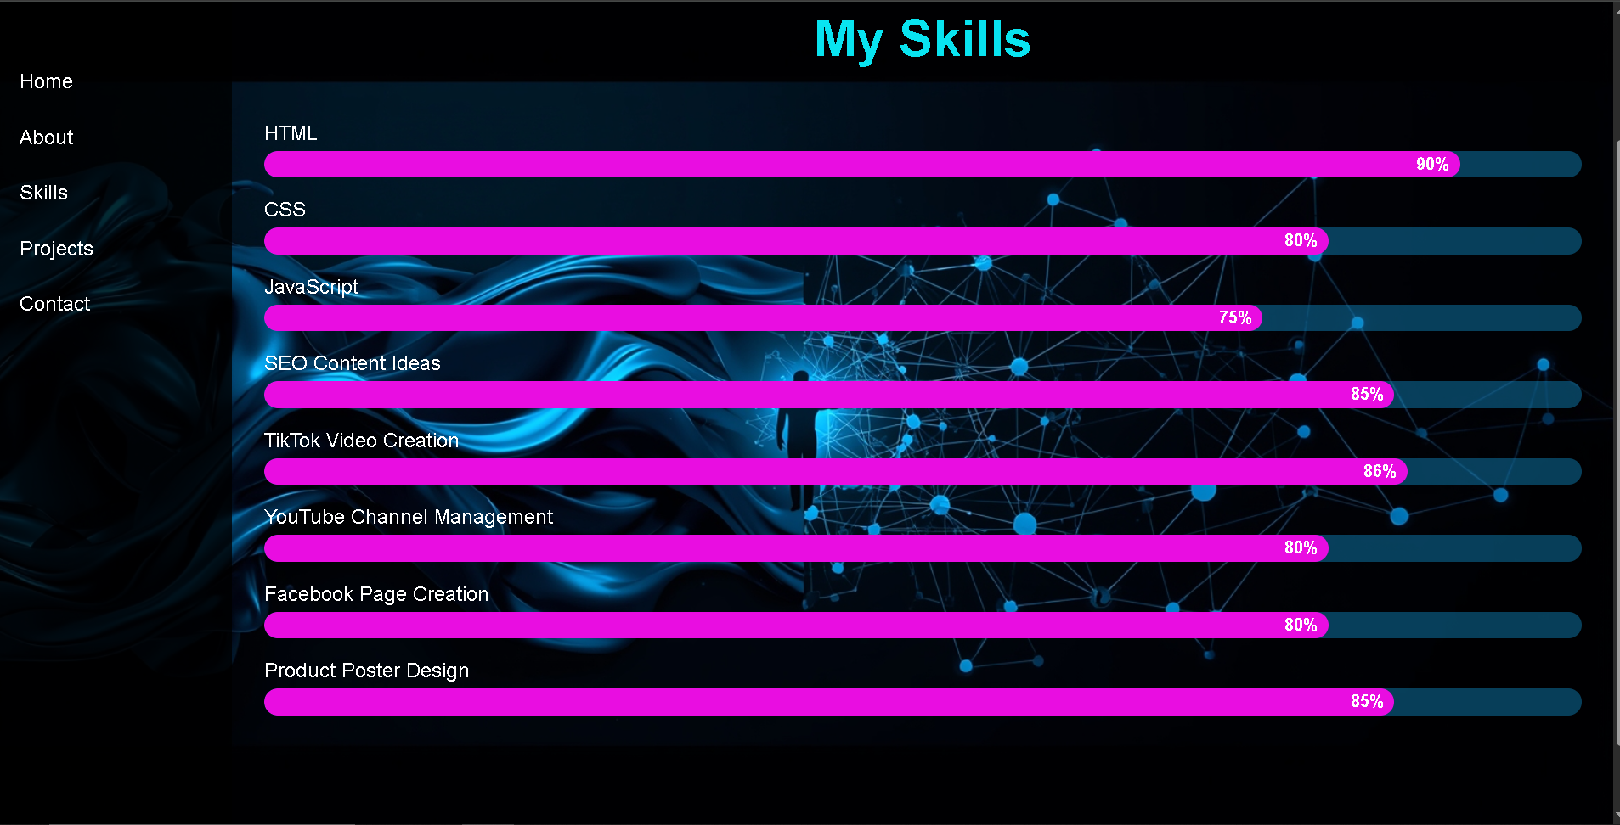

# ****5.4 ) . Projects Page (project.html)****

### **Purpose:**

To showcase the real work I have completed.  
This page builds trust and proofs skills.

### **Project Types Shown:**

* Web design projects
* Mini JavaScript apps
* Portfolio templates
* AI editing projects
* Website layouts
* Social media visuals
* Any real client work

### **Page Layout:**

* Project cards
* Image preview
* Short description
* Title of each project

### **What This Page Shows:**

* My practical experience
* My creativity
* My coding knowledge
* My designing style

### **User Benefit:**

Clients or recruiters see proof of my ability.

------------------------------------------------------------------------------------------------------------------------------------------------------------------------------------------------------------------------------------------

Code:

<!DOCTYPE html>

<html lang="en">

<head>

  <meta charset="UTF-8">

  <meta name="viewport" content="width=device-width, initial-scale=1.0">

  <title>My Projects</title>

  <style>

    body {

      margin: 0;

      font-family: Arial, sans-serif;

      background: url('project background pic.jpg') no-repeat center center fixed;

      background-size: cover;

      color: #fff;

    }

    /* Navigation */

    nav {

      width: 220px;

      height: 100vh;

      position: fixed;

      top: 0;

      left: 0;

      background-color: rgba(0,0,0,0.85);

      display: flex;

      flex-direction: column;

      padding-top: 50px;

      z-index: 100;

    }

    nav a {

      color: #fff;

      text-decoration: none;

      font-size: 1.2em;

      padding: 15px 20px;

      transition: 0.3s;

    }

    nav a:hover, nav a.active {

      background-color: #00ffea;

      color: #000;

      border-radius: 10px;

    }

    /* Main Content */

    .main {

      margin-left: 220px;

      padding: 50px 30px;

    }

    h1 {

      text-align: center;

      font-size: 3em;

      margin-bottom: 50px;

      color: #00ffea;

      text-shadow: 2px 2px 4px #000;

    }

    .projects-grid {

      display: grid;

      grid-template-columns: repeat(auto-fit, minmax(300px, 1fr));

      gap: 30px;

    }

    /* Project Card */

    .project-card {

      background-color: rgba(255,255,255,0.1);

      border-radius: 15px;

      overflow: hidden;

      box-shadow: 0 0 20px rgba(0,255,234,0.3);

      transition: transform 0.3s, box-shadow 0.3s;

    }

    .project-card:hover {

      transform: scale(1.05);

      box-shadow: 0 0 35px rgba(0,255,234,0.7);

    }

    .project-card img {

      width: 100%;

      display: block;

      object-fit: cover;

      height: 200px;

    }

    .project-info {

      padding: 20px;

      text-align: center;

    }

    .project-info h3 {

      color: #00ffea;

      margin-bottom: 10px;

    }

    .project-info p {

      color: #fff;

      font-size: 1em;

      margin-bottom: 10px;

    }

    .project-info a {

      text-decoration: none;

      color: #000;

      background-color: #00ffea;

      padding: 10px 20px;

      border-radius: 25px;

      transition: 0.3s;

    }

    .project-info a:hover {

      background-color: #d9f104;

      color: #000000;

    }

    footer {

      text-align: center;

      padding: 20px;

      background-color: rgba(0,0,0,0.7);

      margin-top: 50px;

    }

    /* Responsive */

    @media(max-width: 768px){

      nav {

        width: 100%;

        height: auto;

        position: relative;

        flex-direction: row;

        justify-content: space-around;

        padding: 10px;

      }

      .main {

        margin-left: 0;

        padding: 20px;

      }

    }

  </style>

</head>

<body>

  <!-- Navigation -->

  <nav>

    <a href="Index.html">Home</a>

    <a href="about.html">About</a>

    <a href="skills.html">Skills</a>

    <a href="project.html" class="active">Projects</a>

    <a href="Index.html">Contact</a>

  </nav>

  <!-- Main Content -->

  <div class="main">

    <h1>My Projects</h1>

    <div class="projects-grid">

      <!-- 1. Car Showroom Website -->

      <div class="project-card">

        <img src="car web [ic.png" alt="Portfolio Website">

        <div class="project-info">

          <h3>Website Developer | Car Showroom</h3>

          <p>Dark theme Car Showroom built using HTML, CSS, JS.</p>

          <p>Best Performance Developer</p>

          <br>

          <a href="https://1111996-stack.github.io/car_website/">View Live</a>

        </div>

      </div>

      <!-- 2. YouTube Project -->

      <div class="project-card">

        <img src="chanal.jpeg" alt="YouTube Content Setup">

        <div class="project-info">

          <h3>YouTube Content Setup</h3>

          <p>SEO Titles, Thumbnails & Viral Strategy.</p>

          <p>Channel Growth Expert</p>

          <br>

          <a href="https://www.youtube.com/@Easy_channel971">View Details</a>

        </div>

      </div>

      <!-- 3. Poster Designing -->

      <div class="project-card">

        <img src="poster.png" alt="Poster Designing">

        <div class="project-info">

          <h3>Poster Designing</h3>

          <p>Creative Poster Designing for brands.</p>

          <a href="#">View Details</a>

        </div>

      </div>

      <!-- 4. AI Content Creation -->

      <div class="project-card">

        <img src="content.png" alt="AI Content Creation">

        <div class="project-info">

          <h3>AI Content Creation Expert</h3>

          <p>Master in generating AI images, talking-avatar videos, viral scripts, social media captions, thumbnails, and complete content workflow using top AI tools.</p>

          <br>

          <a href="https://www.youtube.com/@Easy_channel971">View Details</a>

        </div>

      </div>

      <!-- 5. AI Images Creation Master -->

      <div class="project-card">

        <img src="Phoenix_09_A_closeup_portraitstyle_moment_Jesus_face_determine_1.jpg" alt="AI Images Creation Master">

        <div class="project-info">

          <h3>AI Images Creation Master</h3>

          <p>High-Quality AI Art & Creative Visuals.</p>

          <p>Professional AI Image Creation</p>

          <p>AI Video Creator</p>

          <br>

          <a href="all_ai_images.html">View Details</a>

        </div>

      </div>

      <!-- 6. Portfolio Website -->

      <div class="project-card">

        <img src="my portfilooooooooooo.png" alt="Portfolio Website">

        <div class="project-info">

          <h3>Portfolio Website</h3>

          <p>Modern & responsive personal portfolio website built with HTML, CSS, and JS.</p>

          <p>Showcases my skills, projects, and AI content creations.</p>

          <br>

          <a href="portfolio.html">View Code & Demo</a>

        </div>

      </div>

    </div>

  </div>

  <!-- Footer -->

  <footer>

    © 2025 My Portfolio — All Rights Reserved

  </footer>

</body>

</html>

**Page Output:**

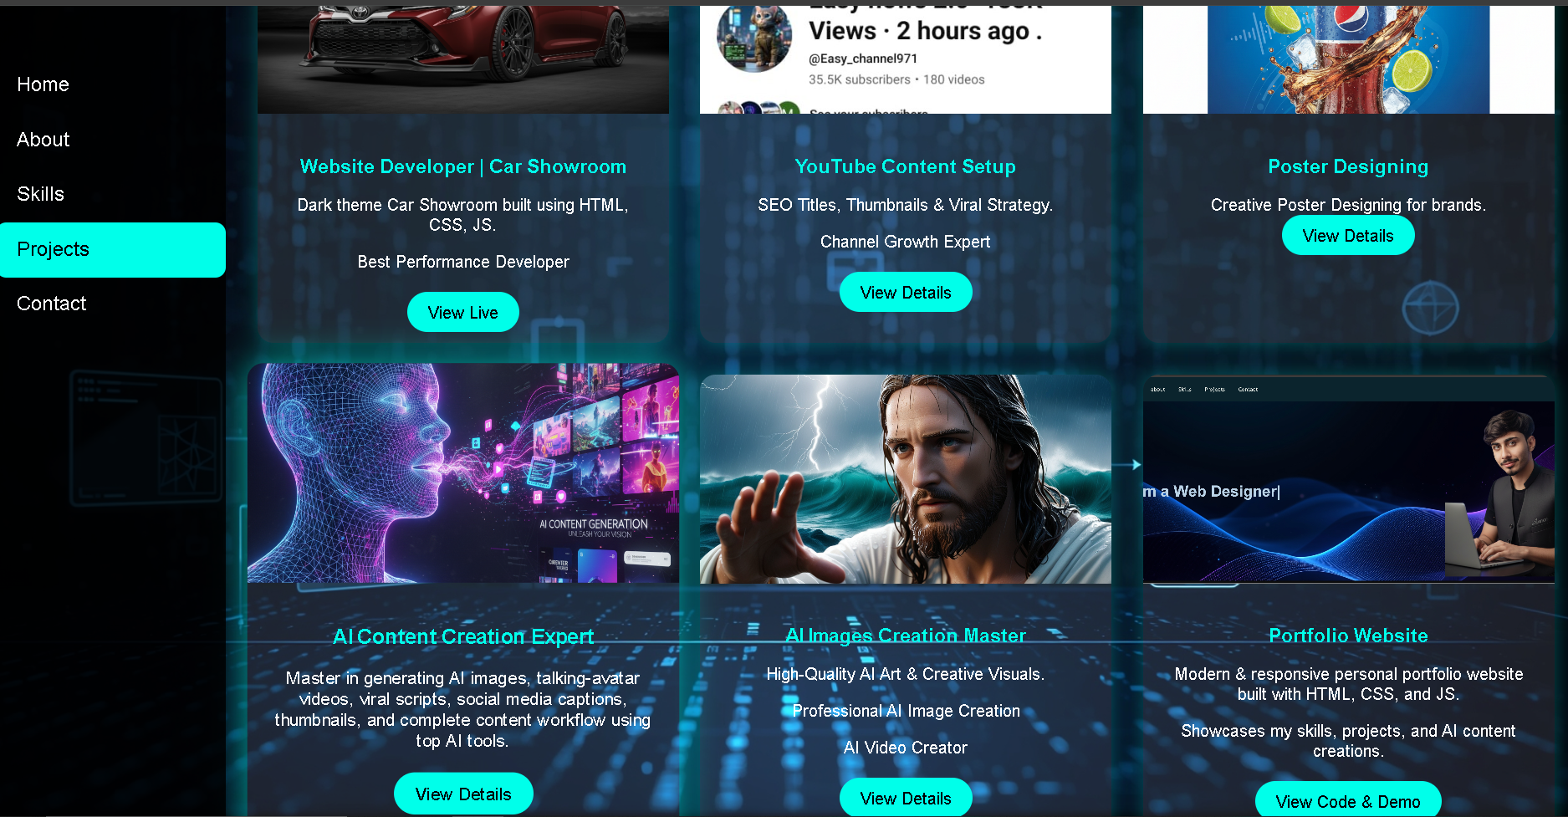

# ****5.5 ) . AI Images Page (all_ai_images.html)****

### **Purpose:**

This html file is inside of project.html it contain my all ai created images and video

Show the AI-generated images that I have created using different tools / prompts.

### **Types of Images Included:**

* Portrait AI images
* Creative AI art
* Cinematic AI frames
* Photoshop-like AI edits

### **Page Features:**

* Grid gallery layout
* Beautiful thumbnails
* Organized images
* Light/dark theme matching

### **What This Page Shows:**

My creativity and capability in the modern AI world.

Code:

<!DOCTYPE html>

<html lang="en">

<head>

  <meta charset="UTF-8">

  <meta name="viewport" content="width=device-width, initial-scale=1.0">

  <title>AI Images Creation</title>

  <style>

    body {

      margin: 0;

      font-family: Arial, sans-serif;

      background: #000;

      color: #00ffea;

      padding: 30px;

    }

    h1 {

      text-align: center;

      font-size: 3em;

      margin-bottom: 40px;

      text-shadow: 0 0 10px #00ffea;

    }

    .gallery {

      display: grid;

      grid-template-columns: repeat(auto-fit, minmax(250px, 1fr));

      gap: 25px;

    }

    .gallery img {

      width: 100%;

      height: 250px;

      object-fit: cover;

      border-radius: 15px;

      box-shadow: 0 0 15px #00ffea;

      transition: 0.3s;

    }

    .gallery img:hover {

      transform: scale(1.06);

      box-shadow: 0 0 25px #00ffea;

    }

    .video-box {

      margin-top: 40px;

      text-align: center;

    }

    video {

      width: 90%;

      max-width: 700px;

      border-radius: 15px;

      box-shadow: 0 0 20px #00ffea;

    }

    a.back {

      display: block;

      margin: 40px auto;

      width: 200px;

      text-align: center;

      padding: 12px 20px;

      background: #00ffea;

      color: #000;

      font-size: 1.2em;

      text-decoration: none;

      border-radius: 25px;

      transition: 0.3s;

    }

    a.back:hover {

      background: #d9f104;

    }

  </style>

</head>

<body>

  <h1>AI Images Creation Gallery</h1>

  <!-- 6 AI IMAGES -->

  <div class="gallery">

    <img src="Lucid_Origin_A_young_Baloch_boy_standing_in_the_rugged_mountai_1.jpg" alt="">

    <img src="11111.jpg" alt="">

    <img src="Lucid_Origin_Un_leopardo_alto_y_majestuoso_con_un_pelaje_de_co_2.jpg" alt="">

    <img src="22222.jpg" alt="">

    <img src="Lucid_Origin_exquisite_high_fashion_photography_of_A_white_cat_2.jpg" alt="">

    <img src="33333.jpg" alt="">

  </div>

  <!-- 1 Video -->

  <div class="video-box">

    <h2 style="text-shadow:0 0 10px #00ffea;">AI Video Creation</h2>

    <video controls>

      <source src="WhatsApp Video 2025-11-22 at 1.24.28 PM.mp4" type="video/mp4">

    </video>

  </div>

  <!-- Back Button -->

  <a href="project.html" class="back">⬅ Back to Projects</a>

</body>

</html>

----------------------------------------------------------------------

**Page Output:**

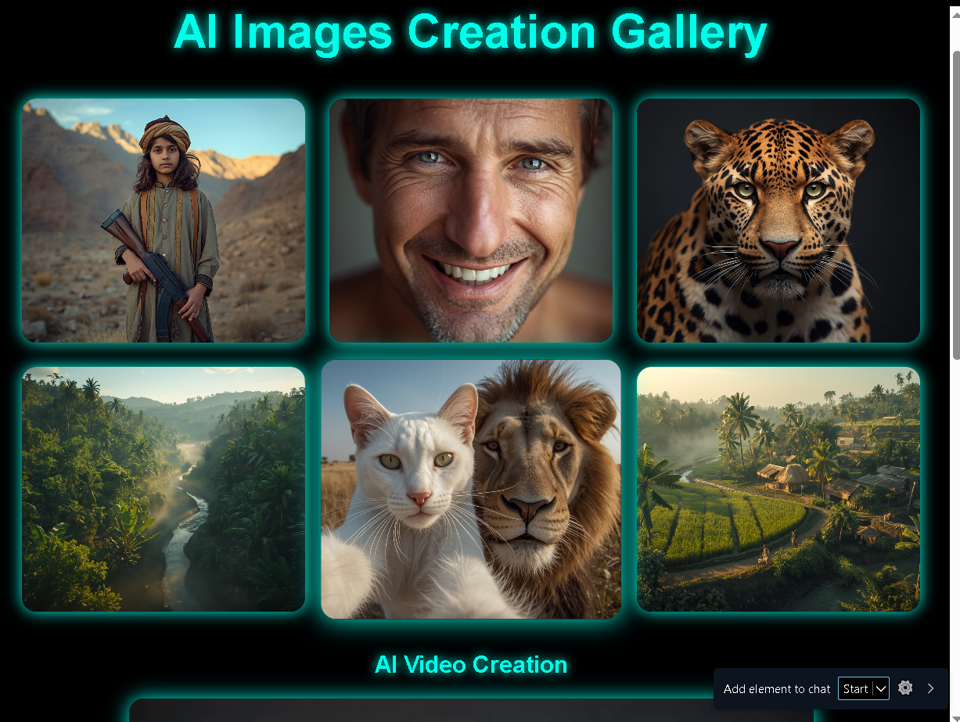

----------------------------------------------------------------------

# ****5.6 ) . Contact Page (contact.html / inside index.htm)****

### **Purpose:**

Allow visitors to send a message or contact me for work.

### **Form Fields:**

* Name
* Email (with validation)
* Message

### **Backend:**

Formspree API – sends message directly to my email.

### **Page Features:**

* Clean form layout
* Minimalistic design
* Button hover effect
* Error-free submission

### **What This Page Shows:**

Visitors can reach me easily for:

* Work
* Collaborations
* Projects
* Questions

**Code:**

<!-- Contact Section -->

  <section class="section contact" id="contact">

    <h2>Contact Me</h2>

    <form action="https://formspree.io/f/xgvqyeon" method="POST">

      <input type="text" name="name" placeholder="Your Name" required>

      <input type="email" name="email" placeholder="Enter your Own Email" required>

      <textarea name="message" placeholder="Your Message" required></textarea>

      <button type="submit">Send Message</button>

    </form>

  </section>

=================================================================================

**Css**

   .contact {

      background-color: #020c1d2e;

      color: #0ae6ee;

      border-radius: 15px;

      padding: 30px;

    }

    .contact input, .contact textarea {

      width: 90%;

      padding: 10px;

      margin: 10px 0;

      border-radius: 5px;

      border: none;

      background: #191818;

      color: rgb(238, 236, 236);

    }

    .contact button {

      padding: 12px 20px;

      background: #ffffff;

      color: #111111;

      border: none;

      border-radius: 8px;

      cursor: pointer;

      transition: 0.3s;

    }

    .contact button:hover { background: #f3ef06; }

    footer {

      text-align: center;

      padding: 20px;

      background: #111;

      margin-top: 40px;

      color: #777;

    }

    /* Responsive */

    @media (max-width: 768px) {

      .hero {

        flex-direction: column;

        text-align: center;

        height: auto;

      }

      .hero-right img {

        padding-left: 0;

        margin-top: 20px;

        width: 250px;

        height: 250px;

      }

    }

----------------------------------------------------------------------**Page Output:** 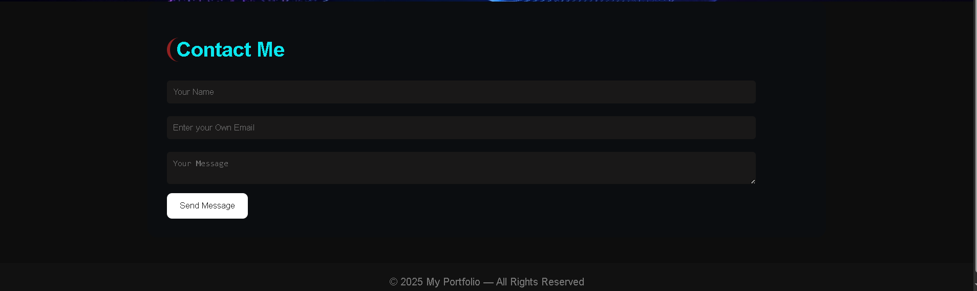

# ----------------------------------------------------------------------

# ****6 ) . Functional Requirements****

### **FR1:** **The system must display a hero section with animated text.**

### **FR2: The navigation bar must link to all sections.**

### **FR3: The profile image must animate horizontally.**

### **FR4: The website must be fully responsive.**

### **FR5: Users must submit messages through the contact form.**

### **FR6: Email format validation must be enforced.**

# ****7 ) . Non-Functional Requirements****

### **6.1 Performance**

* Fast loading
* Lightweight code
* Minimal scripts

### **6.2 Usability**

* Easy to navigate
* Clean visual hierarchy
* Consistent design

### **6.3 Reliability**

* Contact form works through API
* No broken links

### **6.4 Maintainability**

* Clean, readable code
* CSS structured clearly
* Easy to update new projects

# ****8 ) . Conclusion****

This portfolio website is a professionally structured, visually appealing, and fully responsive digital identity for me. It effectively showcases my skills, projects, AI creativity, and services in a clean and modern format.

The system is simple yet powerful, focusing on:

* Strong first impressions
* Professional presentation
* Easy communication
* Creative display

{ THANK YOU }